When you first open up the page (http://web2014.picoctf.com/delicious-5850932/login.php), you’ll see something like this: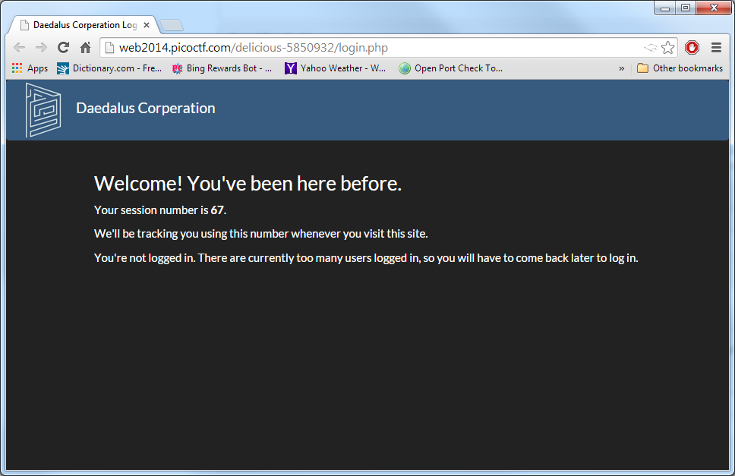

As stated by the hint, you have to change your session number by changing your cookies.

For chrome, I pressed F12 to open up the browser console. Then I clicked the “Resources” tab which gives you a list of categories.

Open up the “Cookies” and you’ll see that for web2014.picoctf.com, there’s a “session_id” Field name and its value will be your current session number.

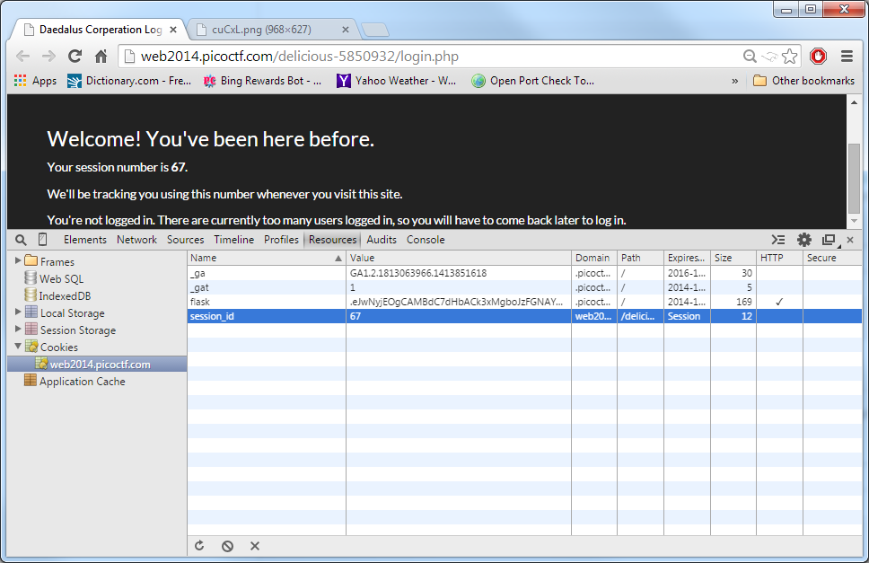

There should be other sessions before yours so what you would have to do is change your session number to a previous session.

To do this, you’ll have to edit your cookie.

I used this link as reference: <http://blog.creativeitp.com/posts-and-articles/javascript/javascript-injection-cookie-editing/>

To change the cookie, just go into the browser console and type:javascript:**void**(document.cookie="session_id=APreviousSessionNumber");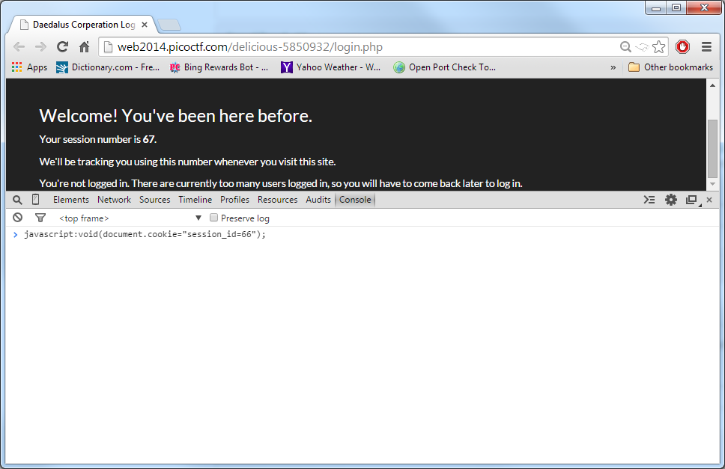

Then just refresh the page and you should be in with the new session number that you chose.

